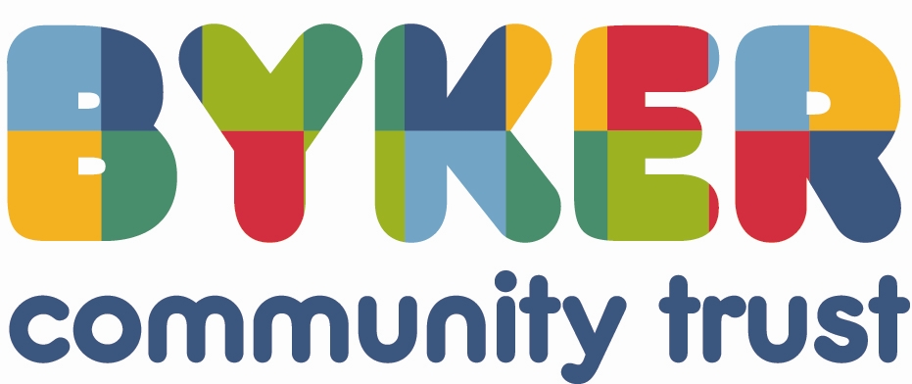

Role Description and Person Specification including Competencies – Non-Executive Director

Introduction

BCT is a Housing Association which was established in July 2012 following the successful ballot of Byker residents, proposing the transfer of the estate from Newcastle City Council to an independent body in order to:
- Secure the much needed investment to upgrade the estate;
- Involve residents in greater direction of services on the estate;
- Ensure service reviews led to improvements in the delivery to tenants.

Further information on BCT is set out in the document entitled ‘Byker Community Trust – Briefing for Board Members’.

What’s it Like Being Part of BCT?

Byker is a great place, where a sense of caring for each other prevails. We want you to be proud to be part of an organisation that is making a positive difference to people’s lives and the area where they live.

At BCT we value our people and empower them with the freedom to achieve, we support one another in order to give everyone the chance to do their best.

Our Vision

BCT’s Vision for 2020 is an independent Byker Community Trust where; we have delivered on the major stock transfer promises; we ensure tenants have a key voice and role in decision making; we maximise access for local people into employment, training, health and educational opportunities.

Our Mission

“We work for people who have a voice and influence in our business; we celebrate our diverse neighbourhood; we provide quality homes, environment and services”

Our Values

We will do our best for Byker by being:

Ambitious for people and the community.

Energetic in our work with and for our diverse neighbourhoods.

Innovative in providing excellent services.

Open and transparent in the conduct of our business.

Unrelenting in our focus on positive change.

Purpose of Role

- To contribute relevant experience, expertise and insight to add value in the creation of strategy and policy which ensures the longer-term viability and sustainability of the Byker Community Trust (BCT).
- To ensure that business decisions are made to facilitate achievement of the company’s strategy and viability whilst ensuring that the views and interests of all the company’s stakeholders are represented at a strategic level.
- To act as an ambassador for BCT.

Responsibilities

- To set long term objectives for the company and to determine the strategic aims and outcomes required to achieve the Business Plan.
- To drive the development of the company’s Corporate Plan, and provide constructive challenge so as to co-create the Plan.
- To be collectively accountable for the quality and effectiveness of the company’s Corporate Plan and supporting strategies in delivering long term sustainability of the company.
- To ensure that strategic decision making provides context for guiding strategic action through others.
- To contribute to the review and evaluation of present and future opportunities, threats and risks in the external environment and current and future strengths, weaknesses and risks in the internal environment to ensure strategic decision making.

Key Accountabilities

Accountable to: The Chair of the Board
Accountable for: The strategic direction of BCT; the co-ordination of group activities; the provision of high quality, cost-effective, value for money services to customers.

Remuneration

No remuneration as this is a voluntary position. Expenses will be reimbursed in accordance with the BCT expenses procedure.

Leadership

To share with other Board Directors accountability for the strategic direction vision, values and standards of the company and in maintaining its focus on delivering improved outcomes for tenants, customers and other stakeholders.

Performance Monitoring

- To ensure there are agreed annual budgets for both revenue and capital expenditure and an approved treasury strategy, that drives the outcomes set out in the Corporate Plan, Business Plan and underlying strategies.
- To regularly review and monitor performance of the company against the Corporate Plan and Business Plan and to ensure management information provided for governing is both necessary and sufficient to allow the Board to do this.

Risk

To ensure a framework of prudent and effective controls is in place which enables risk to be identified, assessed and managed.

People

Ensure there are systems in place to identify and secure the human resources (capacity and capability) for the company to meet its objectives.

Legal

To ensure the company and its subsidiaries comply with all legal and statutory obligations, and all regulatory requirements are met.

Representation

To enhance the reputation and image of BCT by representing and promoting BCT at key events/interfaces with stakeholders, staff, and customers etc. both internally and externally.

Person Specification and Competencies

Experience

- Recognised significant personal achievement in a management, professional or vocational sphere.
- Relevant experience of the issues/challenges faced by the company and its customers.
- Relevant experience of working with organisations in the not-for-profit/public sector.
- Experience of issues of social exclusion, the drive towards joined–up services and/or neighbourhood/community regeneration.
- Leadership and personal experience of operating in a climate of significant change and challenge.
- Experience of working in a regulated sector.
- Possess skills and knowledge which complement BCT business needs and objectives.

Knowledge

- Understanding of the housing association sector (or another similar) strategic context, competitive environment and stakeholder issues and challenges.
- Commitment to creating new opportunities to engage with and listen to customers and to improve the services which they receive.
- Understanding of the regulatory, legal and other contextual factors impacting on this or similar sectors.
- Understanding of financial/investment appraisal techniques.
- Understanding of the roles and responsibilities of non-executive and executive directors and how to maximize the value added by both.
- Knowledge in one or more of the following areas: housing management and development, asset management, contract management and procuring services, regeneration, community investment, continuous improvement and value for money, finance, risk and treasury management, governance and legal and regulatory requirements, managing budgets and audit.

Skills

- Communication.
- Questioning and listening.
- Business acumen.
- Planning and problem solving.
- Team working.
- Financial awareness (e.g. understanding of how to read and interpret a business balance sheet and key financial documents).

Competencies

For a detailed definition of the competencies below, please refer to the BCT Definition of Competencies.

Essential | Desirable
- Applying Specialist Knowledge | - Analysing and Scrutinising
- Self-management | - Group Decision Making
- Personal Development | - Financial Planning
- Leading and Motivating | - Risk Management
- Directing Strategy | - Performance Monitoring
- Representing | - Governance
- Team Working
- Managing Diversity

